**Project Design Phase-II**

**Data Flow Diagram & User Stories**

|  |  |
| --- | --- |
| Date | 03 October 2023 |
| Team ID | NM2023TMID09431 |
| Project Name | AQUATIC INSIGHTS: COGNOS POWERED WATER PORTABILITY ANALYSIS |
| Maximum Marks | 4 Marks |

**Data Flow Diagrams:**

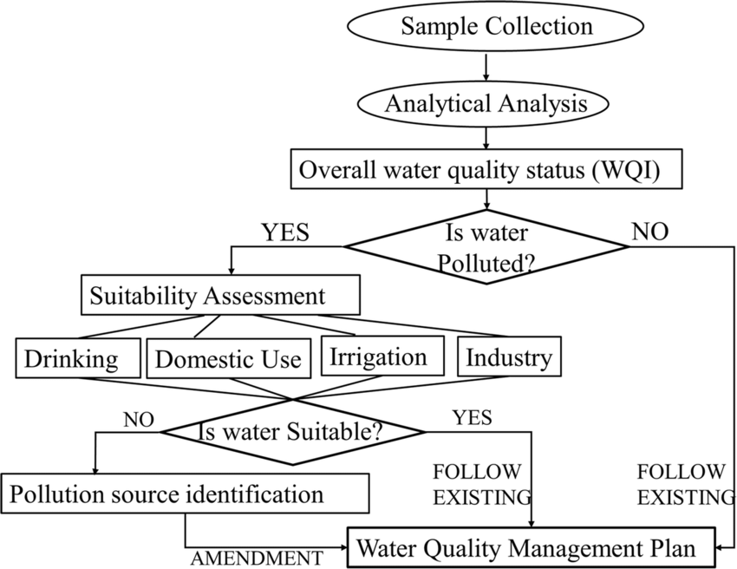

1. Data Collection: Gather data from diverse sources, including water quality reports, environmental sensors, and geographical databases.

2. Data Integration:Combine collected data into a unified format, ensuring compatibility and consistency for meaningful analysis.

3. Data Analysis with Cognos:Utilize IBM Cognos tools to create interactive dashboards and reports, allowing dynamic exploration of water portability metrics.

4. Insight Generation: Analyze patterns and trends within the data to generate actionable insights, identifying areas for improvement and optimization.

5. Decision-Making: Empower stakeholders with the obtained insights, enabling data-driven decisions to enhance water portability strategies and interventions.

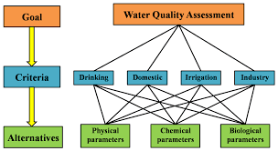

**User Stories:**

| **User Type** | **Functional Requirement (Epic)** | **User Story Number** | **User Story / Task** | **Acceptance criteria** | **Priority** | **Release** |
| --- | --- | --- | --- | --- | --- | --- |
| Customer (Mobile user) | Registration | USN-1 | As a user, I can register for the web application by entering my email, password, and confirming my password. | I can access my account / dashboard | High | Sprint-1 |
|  |  | USN-2 | As a user, I will receive confirmation email once I have registered for the application | I can receive confirmation email & click confirm | High | Sprint-2 |
|  |  | USN-3 | As a user, I can register for the application through Social Media | I can register & access the dashboard | Low | Sprint-1 |
|  |  | USN-4 | As a user, I can register for the application through Gmail | I can register & access the dashboard | Medium | Sprint-1 |
|  | Login | USN-5 | As a user, I can log into the application by entering email & password | I can login & access the dashboard | High | Sprint-3 |
|  | Dashboard | USN-6 | As a user, I can log into the application by entering social media Account | I can login by my account & access the dashboard | Medium | Sprint-4 |
| Customer (Web user) | Web UI | USN-7 | As a user, I can log into nby entering email and password and Access the Features. | I can log in & Enable the Specification | High | Sprint-2 |
| Customer Care Executive | Care Taker | USN-8 | As a user, I can log into by entering Reference number and Reach out the customer for solving issues | I can Resolve the issue and make  Acknowledge | High | Sprint-3 |
| Administrator | Admin | USN-9 | As a Admin, I can Update the Data & UI. | I can update the UI for easy to use. | High | Sprint-1 |